# Greenlabel dashboard documentation

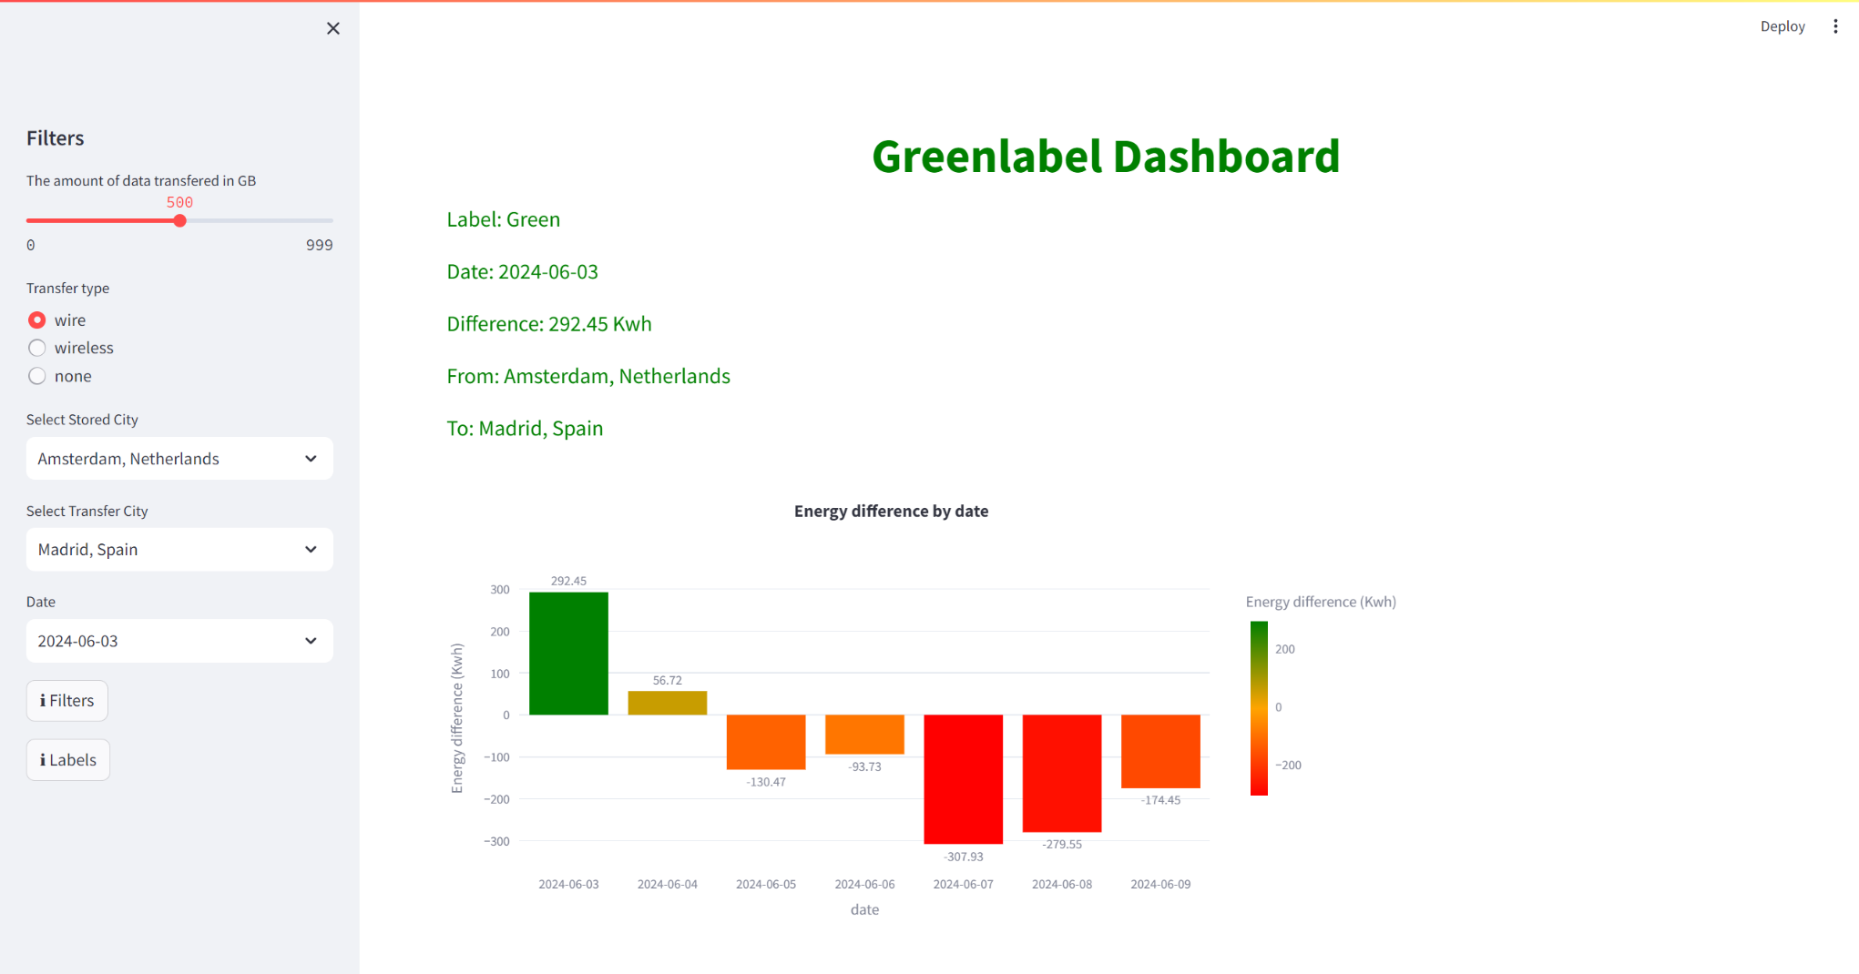

**Goal:**

The goal of this document is to explain the various features in the greenlabel dashboard for all end users. This document will act as a user manual and reference.

**Requirements:**

* An invite to the greenlabel dashboard and/or access to the greenlabel github environment.
* Wifi connection and internet browser.

**Safety & Security: / additional information**

* When the dashboard has not been used for some time streamlit can take it offline temporarily. When coming back to the dashboard for the first time again it will prompt a loading screen and the dashboard will be online again.

**Quality control:**

The validation process will be explained at the end of this document. The greenlabel dashboard is made entirely with python code and libraries. The validation process has been done in Power BI.

**Procedure**

When opening the greenlabel dashboard you will land on the following page shown below.

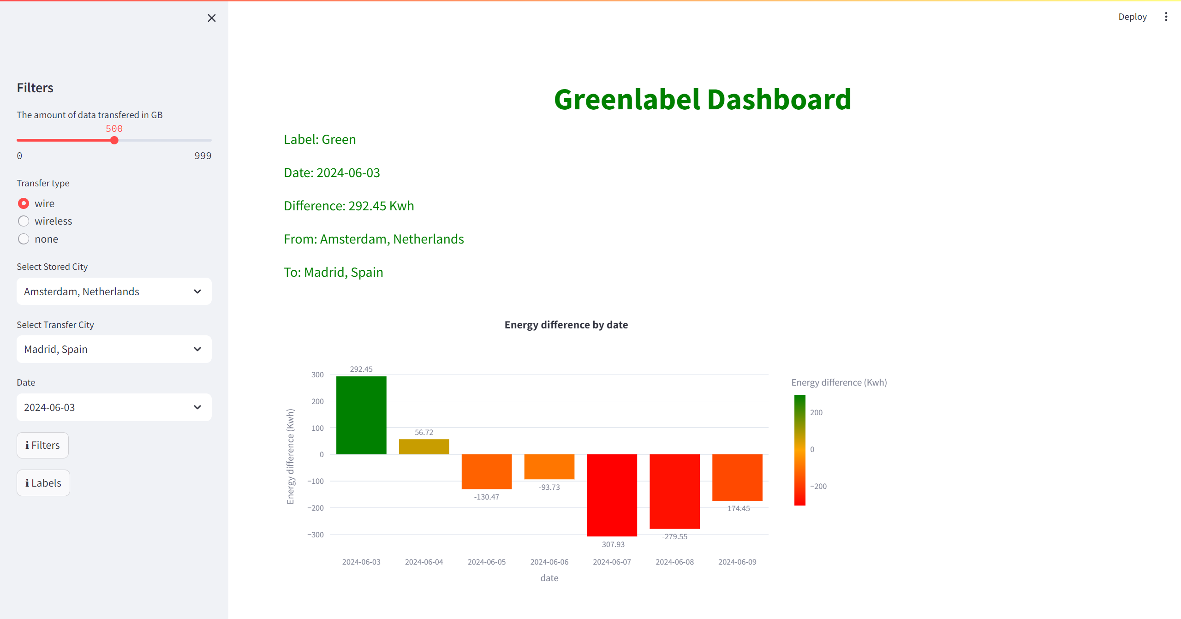

**Filters**

On the left side of the page, you see the filters that are used in the dashboard.

**The amount of data transferred:**

The amount of GB the user wants to transfer.

**Transfer type:**

The method in which the data will be transferred.

**Stored location:**

The location where the data is currently stored.

**Transfer location:**

The location where the user wants to transfer the data to.

**Date:**

The date you want the specific information for.

**Filters button:**

When clicked shows information about the filters.

**Labels button:**

When clicked shows information about the labels.

Changing these filter values will change the ‘Energy difference by date’ visual as well as the label information at the top of the dashboard.

**Labeling information**

On the home screen the labeling information is shown. The information that is displayed depends on the values chosen in the filter pane.

In this example we see that the label is ‘Green’ on the date of 2024-05-17 with a difference of 278.04 Kwh when transferring from Amsterdam to Madrid.

You can see that this label information for the specific date and locations is also visible in the label visualization at the same date on the x-axis.

**Visualizations**

The first visualization you will see when you open the greenlabel dashboard is the ‘energy difference by date’ visual.

In this visual the difference in generated green energy is shown in Kwh. Based on this difference between the selected locations the labels are made.

If the difference is more than 100 Kwh the transfer is deemed beneficial, if the difference is -100 Kwh the transfer is deemed not beneficial and if the difference between the locations falls between -100 and 100 Kwh the transfer could be beneficial (open for interpretation). So a beneficial difference gets the label ‘Green’, a not beneficial difference gets a label ‘Red’ and a possible beneficial difference gets a label ‘Orange’.

When you scroll down in the dashboard you find the ‘Total amount of green energy for every location’ visualization.

This visualization shows the total amount of green energy for every location that can be selected in the filter pane. This could be useful when you want to get a quick overview of all the locations and all their generated energy.

When you scroll further down in the dashboard you find the ‘Solar energy for every location’ visualization.

This visualization shows the total amount of solar energy for every location that can be selected in the filter pane. This could be useful when you want to get a quick overview of all the locations and all their generated solar energy.

When you scroll even further down in the dashboard you find the ‘Wind energy for every location’ visualization.

This visualization shows the total amount of wind energy for every location that can be selected in the filter pane. This could be useful when you want to get a quick overview of all the locations and all their generated wind energy.

**Streamlit plot functionalities**

When you hover over a visualization in the greenlabel dashboard streamlit gives you a few functions / options to visualize the plot further to your liking.

The 1st option is to download the plot as a png image.

The 2nd option is to use the zoom function in the plot.

The 3rd option is to pan which means you can move the plot.

The 4th option is to use the box select which means you can select a specific part of the plot. For example, you can select only the date you are interested in.

The 5th option is the lasso select which does the same thing as the box select only you can select more specifically like a circle or any other form.

The 6th option is the zoom in function which lets you zoom in.

The 7th option is the zoom out function which lets you zoom out.

The 8th option is the autoscale function which resets the plot to how it was originally shown.

The 9th option is the reset axes option which resets the axes of the plot.

The symbol at the end of the options is just a watermark not another function.

**Dashboard validation**